

**Using this Guide**

This guide provides instructions on how to complete a referral to SOAR and how to check the status of the referral once submitted.

***Searching for a Client***

1. Upon log in, you will land on the Client Search page. Users can also navigate to the Search page by clicking the Search button in the top right of the browser window.

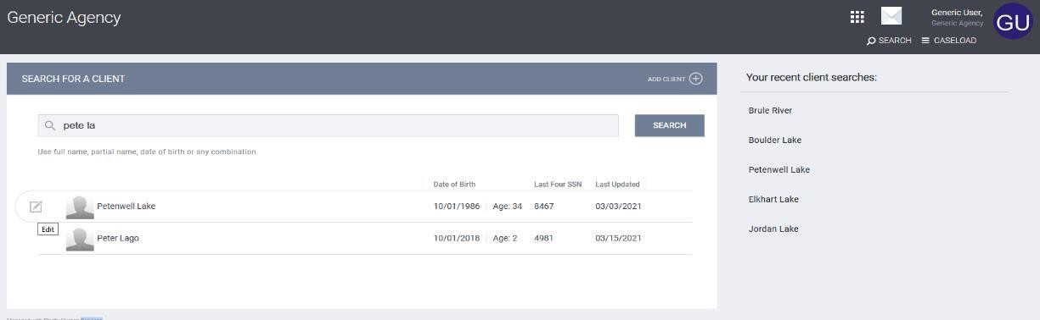

1. To search, enter the client’s information into the Search bar.
2. It is possible to enter “full name, partial name, date of birth (DOB), HMIS#, or Unique Identifier.”
3. In most cases, using partial names in a search query is advised as it reduces the chance of minor spelling variations omitting the client from the query results.
4. For example, as seen above, “pete la” correctly returns the desired client, Petenwell Lake. Of course, more common names may require more specificity.
5. Bitfocus recommends using the first three letters of both the first and last name.
6. If an initial query does not locate the client, it is important to try other combinations including options involving the Date of Birth (DoB) or the last four of the SSN.
7. Check that all unique identifying information matches before selecting a client.
8. If you identify potential duplicate files, please notify your System Admin.
9. To select a client hover over their name until the Edit icon, a small pencil, appears to the left of the name. Click the icon.

***Completing the SOAR Referral Form***

Once the client profile is displayed Click the **ASSESSMENTS** tab

**START** the **SOAR Referral Form** to provide the SOAR Worker will the information needed to determine eligibility.

**NOTE**:

SOAR is a national model designed to increase access to the disability income & benefit programs administered by the Social Security Administration for eligible individuals who are experiencing or at-risk of homeless.

To build community capacity, increase appropriate referrals, assist qualified individuals in accessing SSA benefits, and gather data for a community needs assessment we are asking that Case Managers complete this referral form.

If you have questions, please contact the local SOAR Coordinator, Sheila Crump at 980-314-8928 or [Sheila.Crump@mecklenburgcountync.gov](mailto:Sheila.Crump@mecklenburgcountync.gov)

SOAR SCREENING TOOL

CRITERIA (A): CHRONIC MEDICAL CONDITION:

• Medical condition that lasts more than one year or will result in death

• Unable to work due to illness

• Severe symptoms that prevent ADLs (Activities of Daily Living)

CRITERIA (B) SERIOUS MENTAL DISORDER

• Understanding, remembering or apply information

• Interacting with others

• Concentrate, persist, or maintain pace (as they relate to the ability to complete tasks)

• Adapt or manage oneself (hygiene, responding to change, setting realistic goals)

• Mental illness with symptoms that significantly impact daily functioning

***Completing the SOAR Referral Form in the HMIS***

NOTE: This must be completed before sending the referral in HMIS

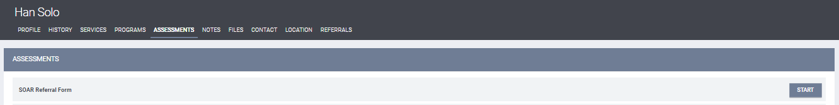

The **SOAR Referral Form** will appear as shown below, please complete all fields and Click **SAVE**.

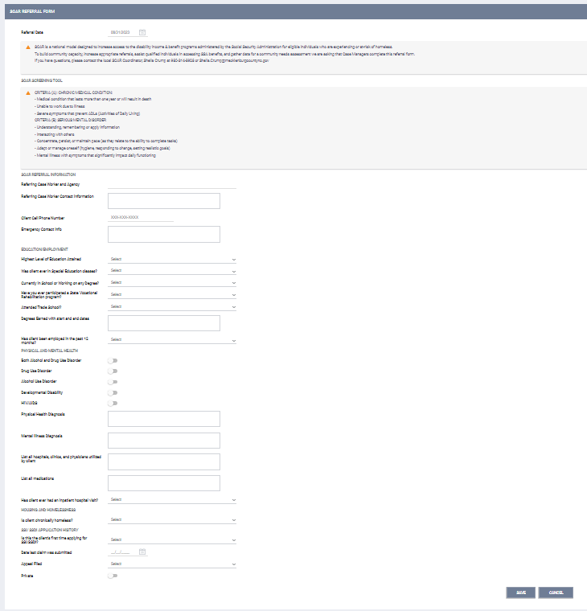

The form will save to the clients **Assessment History** as shown below:

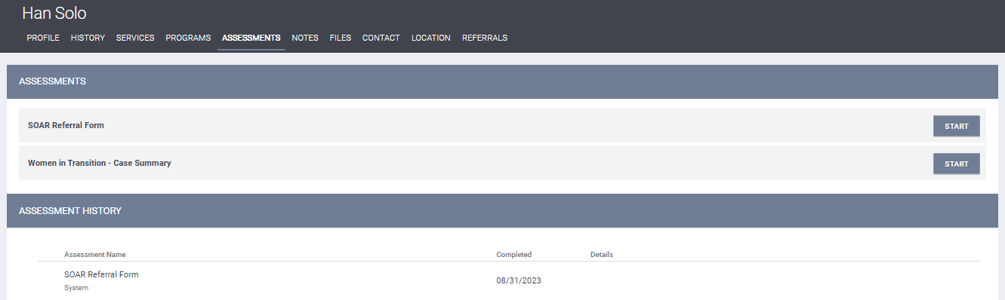

Click the Referrals Tab shown below.

You will be able to search for the **Mecklenburg County Homeless Support Services SOAR Program**

1. BY AGENCY
2. BY PROGRAM CATEGORY

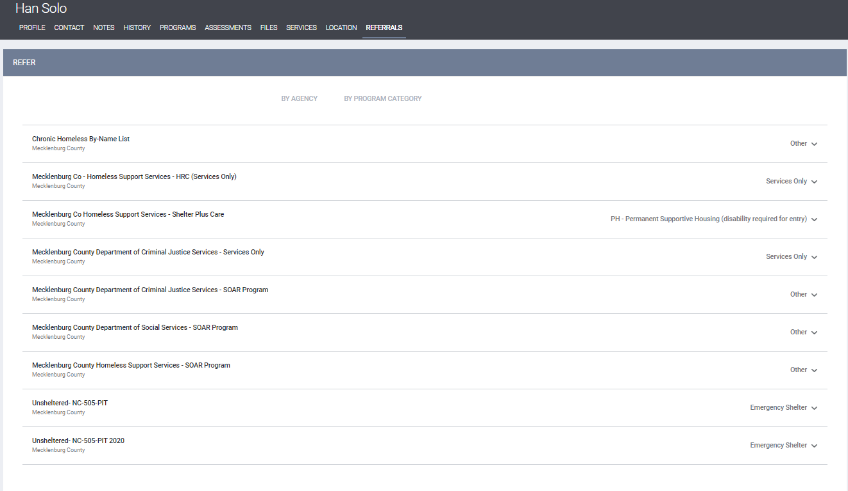

To search BY AGENCY, you will select Mecklenburg County from the drop down.

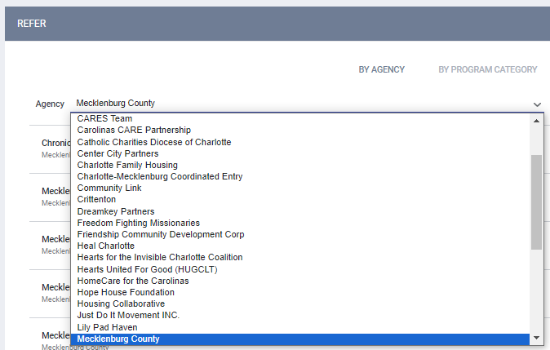

To search BY PROGRAM CATEGORY you will select Other from the drop down

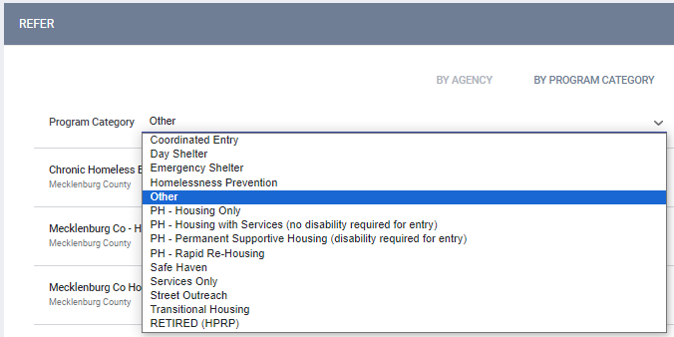

Click on the program from the search screen



You will Click **MAKE REFERRAL**

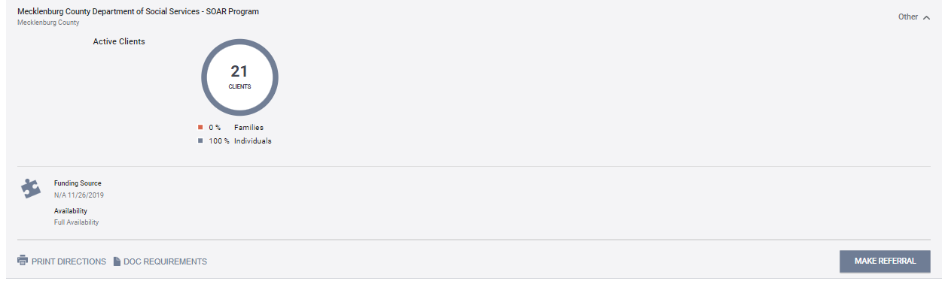

To make the actual referral to the SOAR program you will have to click **SEND REFERRAL**.

**Note:** You will receive an email as well as the SOAR program staff.

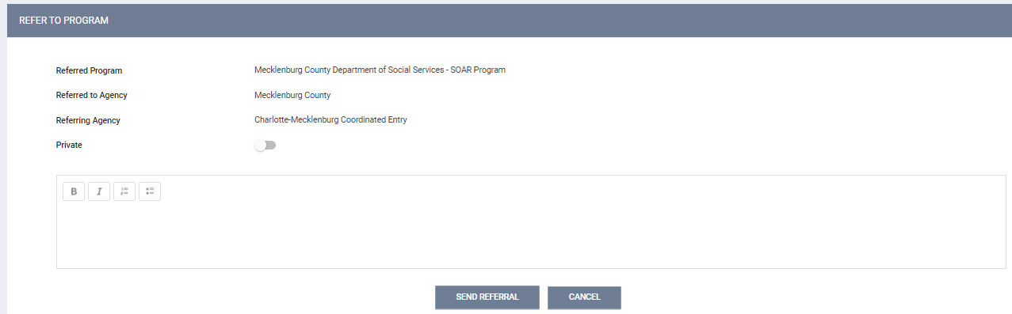

The below screen will appear to select a **Case Manager** is other than the referrer and add any **NOTES** to the actual referral.

Click **SAVE CHANGES** when done entering applicable information.

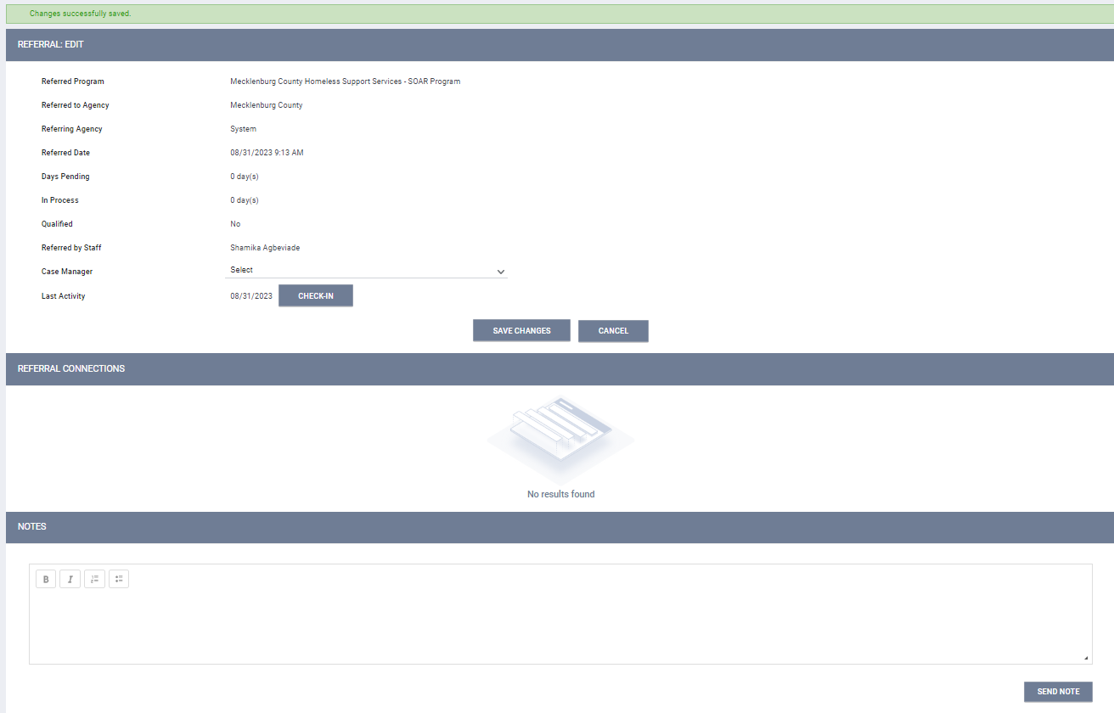

***Checking the status of the SOAR Referral in the HMIS***

The sent referral and referral **Status** will be under the client **HISTORY** tab.

