Exit Destination

The **“exit destination”** of a client is critical in both determining the effectiveness of your program and identifying service gaps in the system. Increasingly, stakeholders want to understand not only how many homeless program participants move into housing, but also how fast and efficiently.

The Exit Destination asks where the client *WILL* be leaving to.

# How Do I Exit a Client from a Program?

The Exit Destination is located on the exit screen. The exit screen exists in any program a client has been enrolled in.

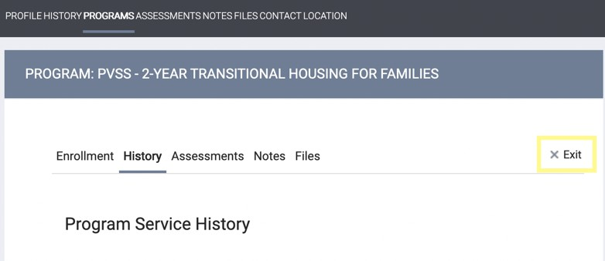

Identify where the client will be staying after being exited from your program (that night). While other enrollment data will auto-populate (cascade) to the exit screen. The clients’ Exit Destination must be entered at the time they are being exited from the program.

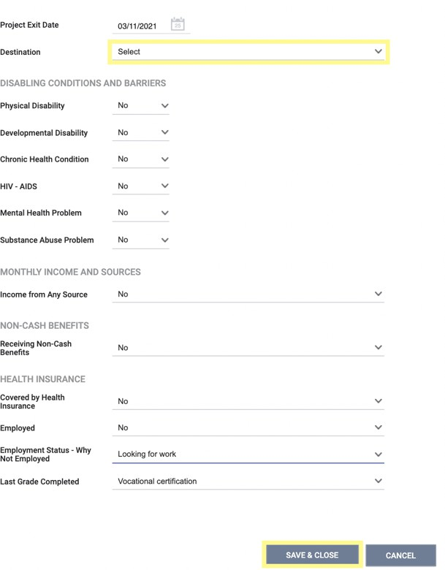

# What is classified as a homeless, institutional, permanent or temporary situation?

|  |  |  |
| --- | --- | --- |
| **Homeless Situations Explanation Local Example** | | |
| **Place not meant for habitation (e.g., a vehicle, an abandoned building, bus/train/subway station/airport or anywhere**  **outside)** | The client was, or will be living outside or any place not meant for human habitation (e.g. a vehicle, abandoned building, bus/train/subway/airport station, campsite) | A vehicle, abandoned building, bus/train/subway/airport station, campsite, storage unit, shed, etc... |
| **Emergency shelter, including hotel or motel paid for with emergency shelter voucher, or RHY-funded Host Home shelter** | The client was, or will be living in an Emergency Shelter, including a hotel or motel paid for with an emergency shelter voucher, non-profit organization, or Federal/State/Local agency. Includes Domestic Violence shelter, Basic Center shelters/host home for youth, and  Missions | Roof Above Men’s Shelter-Rooms in the Inn, Salvation Army Center of Hope-Church in the City, Sunshine Village, The Relatives Youth Crisis Center, Safe Alliance, Samaritan House, PRN Respite, etc… |
| **Safe Haven** | A form of supportive housing that serves hard-to-reach persons experiencing homelessness with severe mental illness and/or substance use disorders who are on the street and have been unable or unwilling to participate in supportive services. | Please reach out to the HMIS helpdesk ([HMIS@MeckNC.Gov](mailto:HMIS@MeckNC.Gov)) before selecting this option. |

|  |  |  |
| --- | --- | --- |
| **Institutional Situations Explanation Local Example** | | |
| **Foster care home or foster care group home** | The client was or will be living in a youth (18-24 years old) or child (<18 years old) foster care home or foster care  group home. |  |
| **Hospital or other residential non- psychiatric medical facility** | The client was or will be living in a hospital for any reason other than psychiatric. Includes any residential care  involving a medical need (hospital, rehabilitation center). |  |
| **Jail, prison, or juvenile detention**  **facility** | The client was, or will be living in a local jail, prison (state  or federal) or juvenile detention facility. |  |
| **Long-term care facility or nursing**  **home** | The client was or will be living in a long-term care facility  or nursing home. |  |
| **Psychiatric hospital or other**  **psychiatric facility** | The client was or will be living in a psychiatric facility,  psychiatric hospital, or psychiatric unit of a local hospital |  |
| **Substance abuse treatment facility or detox center** | The client was or will be living in a substance abuse treatment program, detox program or other substance abuse residential facility. | McLeod Addictive Disease Center, Charlotte Rescue Mission Rebound, Anuvia Prevention, & Recovery Center, Hope Haven 90-day treatment, Daymark, etc.. |

|  |  |  |
| --- | --- | --- |
| **Temporary Situations Explanation Local Example** | | |
| **Transitional housing for homeless persons (including homeless youth)** | The client was or will be living in Transitional Housing program that is time limited up to 24 months. Includes TBRA, Youth SHP and Youth transitional housing programs. Does not include an exit to substance abuse treatment facility. | Charlotte Family Housing, My Sister’s House, YWCA, Hope Haven TH, LINK TH, Another Chance House of Refuge, SABER-TH (clients who stay up to 24 months), Hope House, The Harvest Center, etc… |
| **Residential project or halfway house with no homeless criteria** | The client was or will be living in residential project or halfway house that does not have a homeless  requirement. | Oxford House |
| **Hotel or motel paid for without**  **emergency shelter voucher** | The client was or will be living in hotel or motel where the  client pays for their own stay. | Living in Motel/Hotel |
| **Host Home (non-crisis)** | The client was or will be living in a third party’s home, no homeless criteria required. Often a program for clients  aging out of the foster care system. | Time out Youth Host Homes |
| **Staying or living with friends, temporary tenure (e.g. room,**  **apartment, or house)** | The client has exited to a friend’s room, apartment or house occupied by a friend and will stay there only a short  time according to self-report or agency staff report. | Only select temporary if the client tells you that they can only stay for a finite period of time (ex. 3 days). |
| **Staying or living with family, temporary tenure (e.g. room, apartment, or house)** | The client has exited to a family member’s room, apartment or house and will stay there only a short time according to self-report or agency staff report. Use “temporary” if client is given a time limit in which they need to leave, or if the Case Manager has knowledge that  the destination is meant to be very short term. | Only select temporary if the client tells you that they can only stay for a finite period of time (ex. 3 days). |
| **Moved from one HOPWA funded project to HOPWA TH** | HOPWA – Housing Opportunities for Persons with AIDS; TH – Transitional housing |  |

|  |  |  |
| --- | --- | --- |
| **Permanent Situations Explanation Local Example** | | |
| **Staying or living with family, permanent tenure** | The client has moved into a room, apartment or house occupied by a family member and is intending on living there. Use “permanent” if the client has NOT been given a specific time limit in which they need to leave. Includes clients moving into housing with a relative while a  student. | Select this if the living situation has no known end date. |
| **Staying or living with friends, permanent tenure** | The client has moved into a room, apartment or house occupied by a friend and is intending on living there. Use “permanent” if the client has NOT been given a specific  time limit in which they need to leave. | Select this if the living situation has no known end date. |
| **Moved from one HOPWA funded**  **project to HOPWA PH** | HOPWA – Housing Opportunities for Persons with AIDS;  PH – Permanent Housing. |  |
| **Rental by client, no ongoing housing subsidy** | The client was or will be renting a unit they are living in and does not have an ongoing financial support attached  to it. |  |
| **Rental by client, with other ongoing housing subsidy** | The unit the client was or will be renting is being supported by any other subsidy – either government or private, either site-based or voucher. Includes State Rental Assistance (SER), legacy SRO, Pay for Success, and clients who leave for housing provided by college, Job Corps, Military or National Guard training. Does not  include CoC PSH, HOPWA PH, RRH, GPD, or VASH. |  |
| **Owned by client, with ongoing housing subsidy** | The client owned or will own the unit they are living in and has an ongoing housing subsidy (mortgage payment support) attached to it. Includes USDA Rural Development  Loan/Recovery Act Supports. |  |
| **Owned by client, no ongoing housing subsidy** | The client owned or will own the unit they are living in and does not have an ongoing housing subsidy attached  to it. |  |
| **Subsidy Types- Dependent Field** | **Explanation** | **Local Example** |
| **GPD TIP housing subsidy** | The unit the client was or will be renting is being supported by a Grant Per Diem Transition in Place  subsidy. This is a Veteran’s Affairs (VA) funded program. |  |
| **VASH housing subsidy** | The unit the client was or will be renting is being supported by a HUD/VASH subsidy. VASH - Veterans Affairs Supportive Housing. Use only if the client has  moved into the unit. | Through the VA HUD VASH program |
| **RRH or equivalent subsidy** | The unit the client was or will be renting is being subsidized by a Rapid Re-Housing homeless funding source, including: CoC, ESG, SSVF, VA GPD, or Locally-  funded RRH. | RRH, TBRA, SSVF- RRH, HOME ARP TBRA, AWH, MeckHOME, etc… |
| **HCV voucher (tenant or project based) (not dedicated)** | The unit the client was or will be renting is supported by a HUD Housing Choice Voucher (HCV) | Housing First Charlotte Mecklenburg Partnership, Moore Place, The Rise on Clanton, Section 8 Housing Choice Voucher, Emergency Housing Voucher, etc… |
| **Public housing unit** | Should be used if the client is exiting to a unit that is  operated by a public housing agency | Client moved into Inlivian operated/ managed property. Ex. Strawn Towers, Edwin Towers, Southside Homes |
| **Rental by client, with other ongoing housing subsidy** |  | TCLI, Targeted Key Program, Room rental with a subsidy type |
| **Housing Stability Voucher** |  | Our community does not currently have this resource |
| **Family Unification Program Voucher (FUP)** |  | Partnership between YFS & Inlivian |
| **Foster Youth to Independence Initiative (FYI)** |  | Our community does not currently have this resource |
| **Permanent Supportive Housing** | The unit the client was or will be renting is being subsidized by a homeless funding source. This could be a scattered-site or site-based supportive housing where the rental subsidy is from Shelter Plus Care, Supportive Housing Program (PSH), or a local source of subsidy  restricted strictly for homeless persons. | Shelter Plus Care, Supportive Housing Communities-Scattered Site, SHC Healthcare & Housing, Homeless to Homes, Hillrock, MeckFUSE, Keeping Families Together, McCreesh Place, etc… |
| **Other permanent housing dedicated for formerly homeless persons** |  | SABER-OPH (clients who stay longer than 24 months) |

|  |  |  |
| --- | --- | --- |
| **Other Explanation Local Example** | | |
| **No exit interview completed** | The client was unable to be contacted. This will be considered “missing data” for data quality and reporting purposes. This responses should not be used in place of a valid Living Situation response. |  |
| **Other** | Any response of “Other” will not count in any HMIS-based reporting as a positive outcome. | Please reach out to the HMIS helpdesk ([HMIS@MeckNC.Gov](mailto:HMIS@MeckNC.Gov)) before selecting this option. |
| **Deceased** | The client was unable to be contacted. |  |
| **Client doesn’t know** | The client doesn’t know where they were living or where  they will be living. Considered null/missing. |  |
| **Client prefers not to answer** | The client prefers not to tell program staff where they were  living or where they will be living. Considered null/missing |  |
| **Data not collected** | Data was not collected from the client. Considered null/missing. |  |

What if an Exit Interview is not completed?

Clients will leave, or stop participating in, programs at any given time for various reasons. It is important to know that homeless providers are empowered to use their best judgement and logic to fill in data gaps due to unexpected program departures based on conversations with clients and/or client peers. A formal exit interview may not have been completed but you do that the authority to draw logical conclusions based on first-hand knowledge.

For example, let’s say a client gets upset at another client and storms out of the emergency shelter stating, “I’d rather go back to the streets than deal with this!” You may exit the client to a “place not meant for habitation” on their exit screen.