**Adding Housing Plan and Acuity Index to HMIS**

The below are steps to take to complete the Housing Plan, administer the Signature page of the Housing Plan and upload the Acuity Index.

**Adding Housing Plan**

**Step 1:** Search for the client in HMIS. Once located enter the project enrollment via the **Programs** tab.

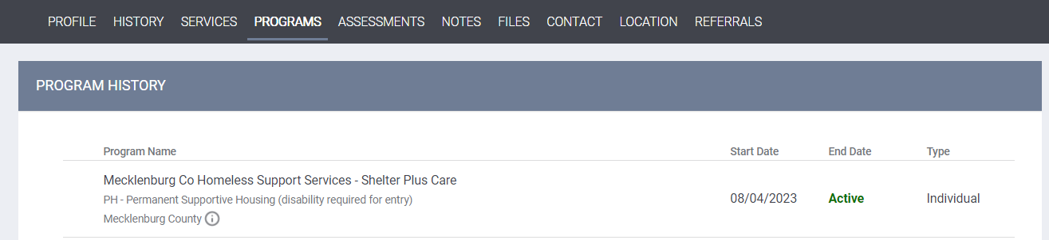

**Step 2:**Click the **Assessment**tab in the white within the project. Select the **Housing Plan NC 505** by clicking *START*.

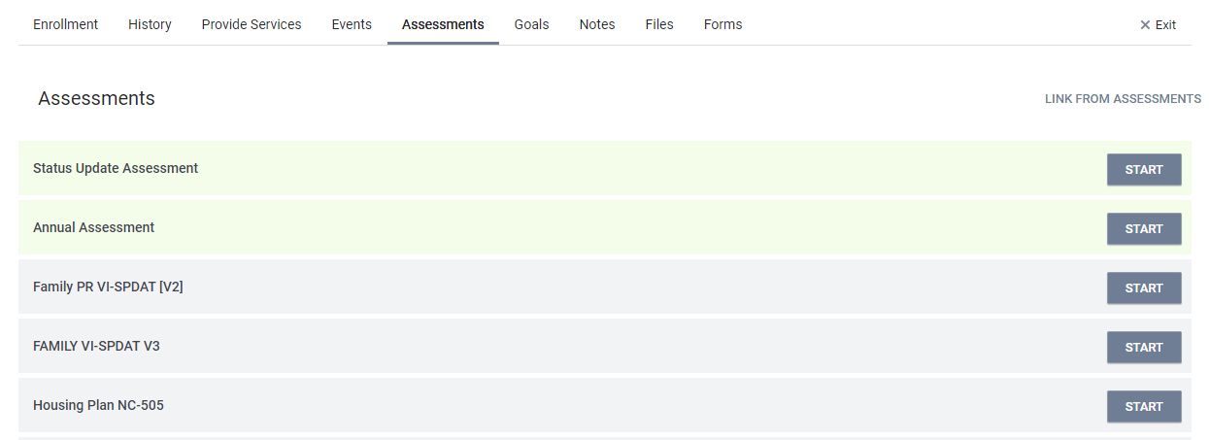

**Step 3:** Complete the assessment and click **SAVE** to Save the assessment when finished.



The assessment will be stored at the bottom of the screen as shown below. Each year will *START* a new file assessment unlike the legacy system so need to print and upload as pdf.

**Adding Housing Plan Signature page**

**Step 1:** Search for the client in HMIS. Once located enter the project enrollment via the **Programs** tab.

**Step 2:** Click the **Forms**tab in the white within the project then Click **ADD FORM**

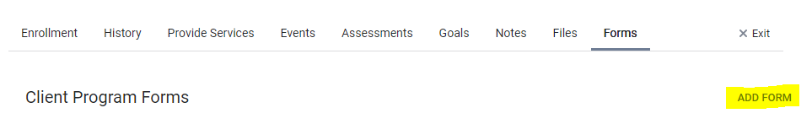

**Step 3:** Select the **Housing Plan NC 505 Signature Page** and click **ADD**

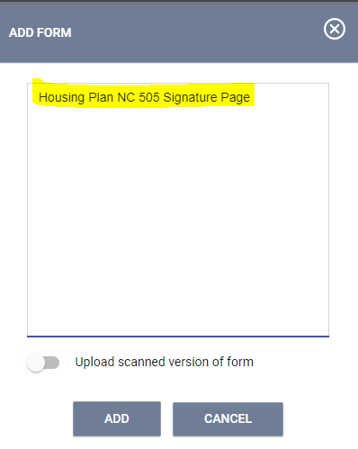

**Step 4:** Have your client toggle on the attestation that they have worked with you to develop and review the plan. The client will sign and Click **APPLY**. You will sign and Click **APPLY**.

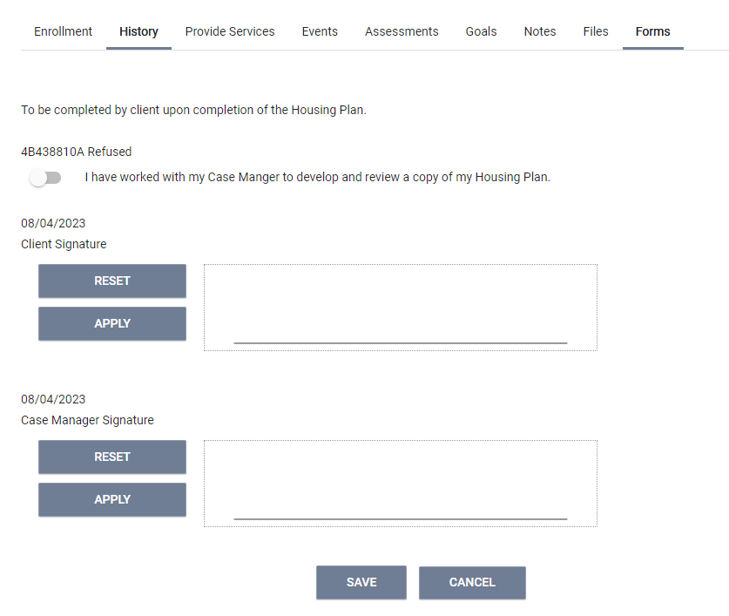

**Step 5:** Click **SAVE** and the signature page will be stored under the **Forms** tab as shown below:

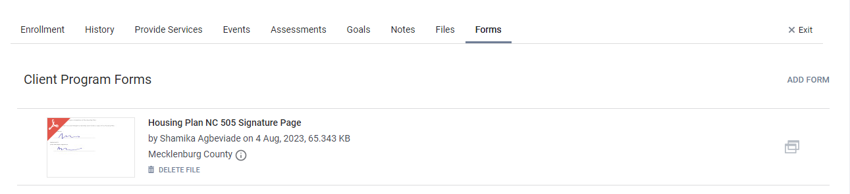

**Adding Acuity Index to HMIS**

**Step 1:** Search for the client in HMIS. Once located enter the project enrollment via the **Programs** tab.

**Step 2:** Click the **Files**tab in the white within the project then Click **ADD FILE.**

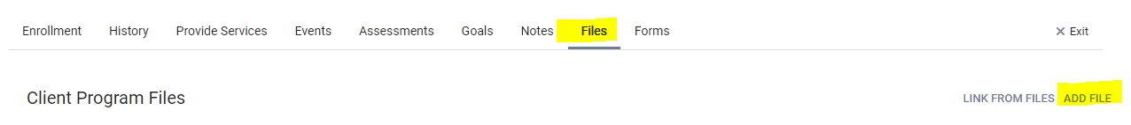

**Step 3:** Click the **Files**tab in the white within the project then Click **ADD FILE.**

**Step 4:** Select **Acuity Index** under *Category*, *Name* will default to **Other**, and Provide *Other Name* (as shown below):

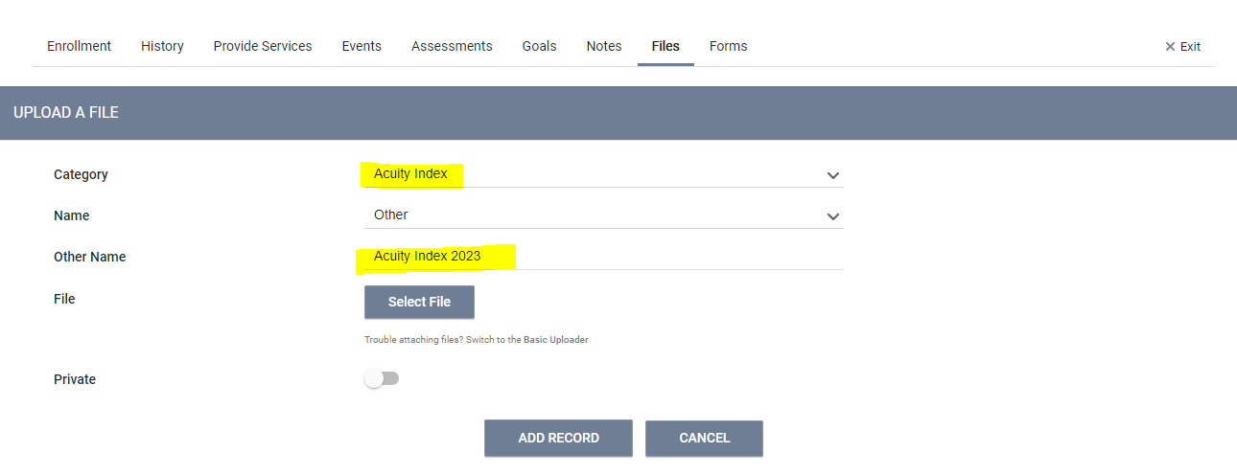

**Step 5:**  Click Select File to upload completed Acuity Index from your computer.

**Step 6:** Click **ADD RECORD** andthe Acuity Index will be stored under the **Files** tab as shown below:

