**A Way Home/ MeckHOME Workflow**

*Enrollmen*t tab

1. The **Project Start Date** should be entered when:
   * the client is eligible
   * a slot if available
   * the client agrees to work with the program
2. The **Housing Move in Date** should be entered to reflect the date the client gains possession to the unit and signs the lease

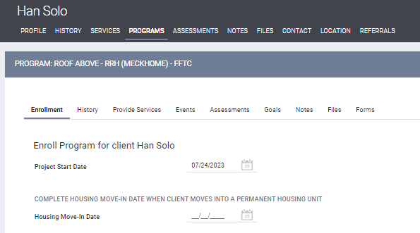

*Assessments* tab

1. The **AWH/MeckHOME Entry Date** should be entered to reflect the date the client gains possession to the unit and signs the lease
2. The **AWH/MeckHOME Monthly Assessment** must be completed monthly
3. The **RRH TH HSF** or **PSH - HSF – Assessment** must be completed monthly to reflect Mecklenburg County Jail and Hospital Utilization
4. **Status Update Assessment** only completed if there is a change with income, non-cash benefits, disability and/or health insurance

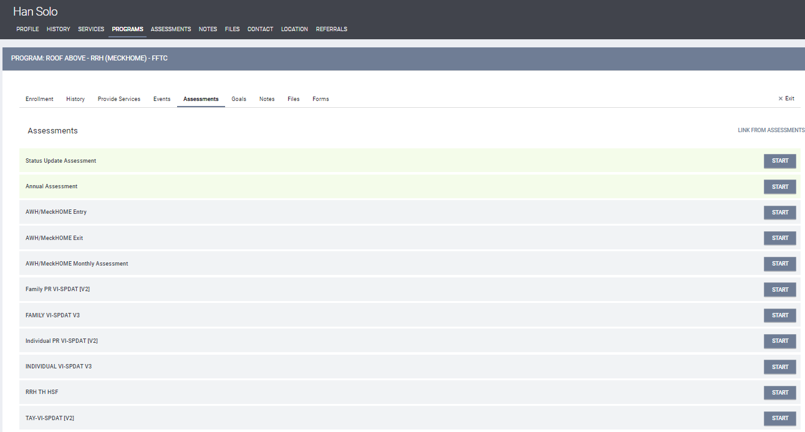

*Provide Services* tab

1. All financial assistance should be entered as a service; ensuring to enter client portions as well as agency assistance

